Coding Assignment 1

1. Write a program which prints a simple numbered menu of a restaurant and asks the user what they want to order. You must use an array to store the menu items, but you may change the restaurant scenario to whatever you like as long as there’s a numbered list involved. It could be choose your character for a game. A sample output is shown below:

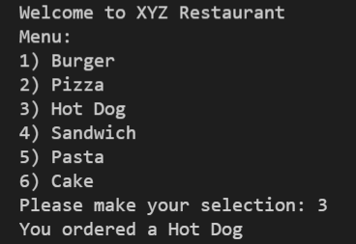

\*BONUS: If the user enters an out of bounds number such as 0 or 7, the program gives an error. Can you handle this better using if/else? Print your own error message for the user.

1. Write a program that asks the user for 3 numbers and then calculates the average using a function with 3 inputs. The signature of this function is given below. Remember that the result of the average can be a decimal number.

public static float average(int a, int b, int c) {

        float result = 0.0f;

        //--------------

        //YOUR CODE HERE

        //--------------

        return result;

    }